

**Provisioning Template for GENERATING CSR/KEY ON SERVER/ADC/AVX**

**User Guide**

|  |  |  |
| --- | --- | --- |
| **Version** | **Remarks** | **Date** |
| **1.0** | **Provisioning Template User Guide for Generating CSR/KEY on SERVER/ADC/AVX** | **25/01/2017** |
| **2.0** | **Updated document with installation of the template.** | **14/02/2017** |
|  |  |  |
|  |  |  |

## Installation of the Template and Helper Script

1. Login to AppViewX.
2. On the left navigation menu, select ***Provisioning***; and click ***Template.***
3. On the upper right portion of the screen click on the  Import button.
4. The following screen will appear. 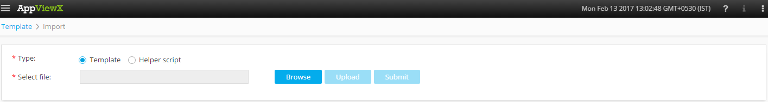
5. Please Select Template/Helper Script.  
   If Template is chosen,
   1. Click on *Browse* and select the Zip File of the template which has to be installed/imported and click open.
   2. Click on upload to import the Zip file and display the templates present in the zip file.
   3. Click on submit to deploy the templates into the AppViewX Environment.

If Helper Script is chosen,

1. Click on *Browse* and select the Zip File of the Helper script which has to be installed/imported and click open.
2. Click on upload to import the Zip file and display the Helper Scripts present in the zip file.
3. Click on submit to deploy the Helper Scripts into the AppViewX Environment.

## Generating CSR/KEY on SERVER/ADC/AVX.

1. Login to AppViewX.
2. On the left navigation menu, select ***Provisioning***; and click ***Request.***
3. On the upper right portion of the screen, click the  ***Create*** button.
4. Select the provisioning template name from the list –‘**CSR and KEY Generator**’

**Note:** *If no template is available, this indicates that the user role does not have permission to the requesting template.*

1. Enter the Provisioning request description – ‘*Generating CSR and Key*’.
2. Enter the Request Scenario Name relevant to the template. ***E.g***.: ‘Generating CSR and Key’.
3. Select the option for which the CSR has to be generated on -**AVX/ADC/Server.**
4. Click on get servers/get devices to get a list of the servers/devices relevant to the option selected above.
5. Choose the **AVX/Server/ADC** from the list populated.
6. Please enter the name of the **Country** in a two alphabet format. ***E.g***.: ‘IN’ (India).
7. Please enter the name of the **State**. ***E.g***.: ‘Tamil Nadu’.
8. Please enter the name of the **Locality**. ***E.g***.:‘Coimbatore’.
9. Please enter the ***name*** of the ***organisation*** for which we are generating the CSR/KEY.
10. Please enter the ***name*** of the ***organisation*** ***unit*** for which we are generating the CSR/KEY.
11. Please enter the ***Common*** ***Name*** for which we are generating the CSR/KEY, It has to be in a FQDN format.
12. Please enter the **Size** of the KEY **1024/2048 bits**.
13. Please enter the **Lifespan** of the KEY in *years*.
14. Please select the option to avail CSR path.  
    If YES is selected,
    1. Please Enter the CSR path. ***E.g***.:‘/home/admin’/.

If No is selected, the default CSR path is selected.

1. Click on *Submit* to generate work order(s) for the provisioning request.